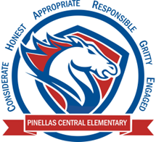

**Pinellas Central Elementary School**

**2nd Grade School Supply List 2025-2026**

**Student Items (for individual student use)**

* **Most important**: 1 pair of **ear buds or headphones** (necessary for computer work; no bluetooth) to stay at school. Please place in a labeled plastic zipper bag.
* 1 backpack
* 4 plastic or paper folders with pockets and prongs (red, blue, green, yellow)
* 4 composition notebooks (all black or red, blue, green, yellow)
* 1 pencil box (to hold all the items listed below at their desk)
  + #2 pencils (standard yellow)
  + 2 big pink erasers and/or eraser pencil caps
  + 1 pack of crayons
  + 1 pack multi-colored colored pencils or markers
  + 1 pair of scissors
  + glue sticks
  + dry erase markers **(black only)**
* 2 packs of sticky notes (varied sizes and colors)

**Supplemental Classroom Items – Donations Welcome**

* plastic zipper bags (all sizes are needed, especially gallon)
* 3 x 5 white index cards
* antibacterial wipes and/or spray
* tissues
* hand sanitizer
* extra #2 pencils
* colored card stock
* construction paper